BLOCKCHAIN FOR VEHICLE REGISTRATION

SULEMAN KHAN

MUHAMMAD ABUBAKAR

SHAHZAIB HASSAN



DEPARTMENT OF COMPUTER SCIENCES

COMSATS UNIVERSITY ISLAMABAD,

ATTOCK CAMPUS – PAKISTAN

SESSION 2017-2021
BLOCKCHAIN FOR VEHICLE REGISTRATION

Undertaken By:

SULEMAN KHAN
CIIT/ SP17- BCS -043/ATK

MUHAMMAD ABUBAKAR
CIIT/ SP17- BCS -050/ATK

SHAHZAIN HASSAN
CIIT/SP17-BCS-034/ATK

Supervised By:

Ma’am TAHIRA SADAF

A DISSERTATION SUBMITTED AS A PARTIAL FULFILLMENT OF THE REQUIREMENTS FOR THE DEGREE OF BACHELOR OF SCIENCE IN SOFTWARE ENGINEERING

DEPARTMENT OF COMPUTER SCIENCES

COMSATS UNIVERSITY ISLAMABAD,

ATTOCK CAMPUS – PAKISTAN

SESSION 2017-2021

UNDERTAKEN

We certify that this is my/our own work. The work has not, in whole or in part, been presented elsewhere for assessment. Where material has been used from other sources it has been properly acknowledged. If this statement is untrue, we acknowledge that we will have committed an assessment offence and shall be liable to punishable action under the plagiarism rules of HEC.

______________ ____________________
Suleman Khan Muhammad Abubakar
SP17-BCS-043 Sp17-BCS-050

Dated: _________ Dated: _________

______________
Shahzaib Hassan
SP17-BCS-034

Dated: _________

FINAL APPROVAL

Certified that we have read this project report submitted by Mr. (Suleman Khan/Muhammad Abubakar/Shahzaib Hassan) and it is, in our judgment, of sufficient standard to warrant its acceptance by Department of Computer Science, COMSATS University Islamabad, Attock Campus, for the BSCS degree.

Committee:

1. External Examiner ____________________________
(Examiner Name)
Designation
University Name

2. Supervisor ____________________________
(Supervisor Name)

3. Chairperson ____________________________
(Chairperson Name)

4. Dean/Director ____________________________
(Dean/Director Name)

DEDICATION

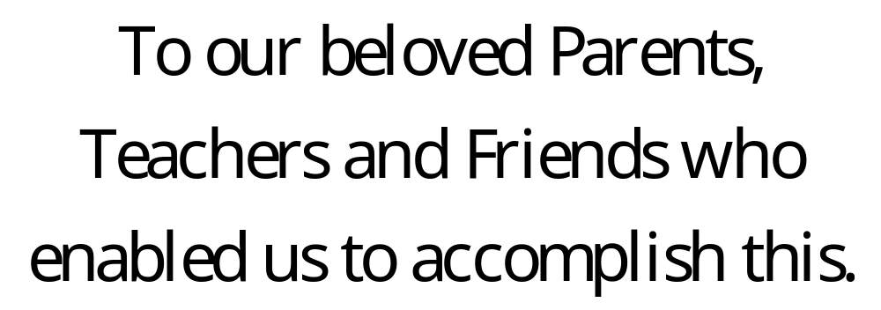

ACKNOWLEDGEMENT

We are grateful that ALLAH gave us this opportunity to work on the project, after that we happily pay gratitude to Mam Tahira Sadaf who fortunately accepted to supervise us in this difficult task.
We would like to express our special thanks to Dr. Tahir and Dr. Saud for accepting our eligibility.
Afterall, it is the prayers of our parents that have accredited us to work on this project.

PROJECT BRIEF

PROJECT NAME /* TITLE / NAME OF THE PROJECT */

ORGANIZATION NAME /* ORG NAME */

OBJECTIVE /* OBJ */

UNDERTAKEN BY /* STUDENT’S FULL NAME */

SUPERVISED BY /* SUPERVISOR NAME */
/* DESIGNATION */
/* DEPARTMENT NAME */
/* UNIVERSITY NAME */

Started On /* START DATE */

Completed On /* END DATE */

COMPUTER USED /* NAME OF COMPUTER */

SOURCE LANGUAGE /* LANGUAGE NAME &VERSION */

OPERATING SYSTEM /* NAME OF OS */

TOOLS USED /* NAMES OF TOOLS */

ABSTRACT

Blockchain enables the development of decentralized distributed network of data sharing system with greater security for important data. In this document we introduce a car registration system based on the decentralized blockchain technology. This system considers several government entities in a single country but could be extended to a cross-border governments, possibly supporting vehicle data sharing at the International Level.
The system Blockchain for vehicle registration handles the processes related to car registration for example, registering a vehicle to the government database, transfer the vehicle ownership and send the registration for the driving license. This system can simplify the information exchange among multiple states as the car registration information is distributed to each government entity in a single decentralized system. We analyze the benefits and implications of the blockchain technology and present an evaluation of the system’s performance and security.
TABE OF CONTENTS
CH# TITLE PAGE NO
CH#1 INTRODUCTION TO BLOCKCHAIN 7
  - Brief 8
    - How it works 8
    - Distributed database system 9
    - A network of nodes 10
  - Background 10
    - Current vehicle registration system 10
    - Smart contract 10
    - Consensus 11
      - Proof-of-work 11
  - Analysis from Literature Review 11
  - Methodology 12

CH#2 PROBLEM DEFINATON 13
2.1 Problem Statement 14
2.2 Deliverable and Development Requirement 15

CH#3 REQUIREMENT ANALYSIS 16
3.1 Use Case Diagram(s) 17
3.2 Functional Requirement 17
3.3 Non-Functional Requirement 18

CH#4 DESIGN AND ARCHITECHER 19
4.1 System Architecture 20
4.2 Entity Relationship Diagram 20

CH#5 IMPLIMENTATION AND EXECUTION 21
5.1 Algorithm 22
5.2 User Interface 22
CH#6 TESTING AND EVALUATION 21
6.1 Testing and Evaluation 22

CH#7 CONCLUSION AND FUTURE WORK 21
7.1 Conclusion 22
7.2 Future work 22

Chapter 1

Introduction to Blockchain

  - Brief

Blockchain is the backbone of Digital Cryptocurrency Bitcoin. The Blockchain is a decentralized distributed database. It contains each single data into records for many years without having any chance of loosing it. Bitcoin is the most popular cryptocurrency an example of the blockchain that contains the records of the transactions. Blockchain Technology first came to light when a Group of individuals name ‘Satoshi Nakamoto’ published a white paper on “Bitcoin: A peer to peer electronic cash system” in 2008. This decentralized system provided by blockchain technology considered a direct competitor to organizations depend on a centralized business model, such as banks and governments. However, many organizations also look at blockchain technology as an innovation that is an opportunity for them to improve their efficiency.
Considering the ability of blockchain technology, the main objective of this chapter is to introduce a car registration system based on blockchain. A car registration system based on blockchain technology can decentralize the old way of registries and enhance data availability and resistance to faults. A decentralized system based on blockchain can improve performance and security when compared with a centralized system.

    - How it works
The most famous use of Blockchain is Bitcoin. It uses cryptographic proof instead of third-party trust for two parties to execute transactions over the internet. Each transaction protects through digital signature. The same will be the working of the data send to the network to be approved from the other nodes. After the approval of the data form the other nodes in the blockchain network, the data will be added to the requested node and then broadcast to the network to update all the other nodes with the new data. The given fig 1.1 will help you to understand easily.
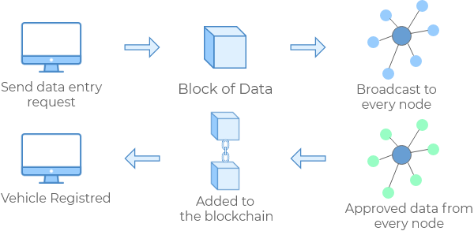
Figure 1 Working of Blockchain

    - Distributed Database System
There is no central system that keeps the data of the blockchain. The data is kept on the different systems connected with the blockchain. The data kept on the different systems are not the different parts of the data, but it is the copies of the data. The figure given below is showing the centralized, decentralized and the distributed data systems.
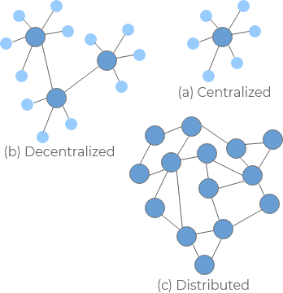
Figure 2 Network of Blockchain

    - A Network of Nodes
A node is a computer connected in the blockchain. When a computer connects to the blockchain, a copy of the blockchain data get downloaded into the computer and the nodes comes into the sync with the latest blockchain data. A node connected with the blockchain executes the algorithms for data verification are called miners.

  - Background
In this section we will discuss the background that is relevant to our work. First, we discuss an overview of how car registration works today. Then, we introduce the concept of smart contract, which is at the core of most applications based on blockchain.

1.2.1 Current Car Registration System
A car registration system, using by the many government entities around the world are centralized system. This information system keeps the records of car registrations are stored into the central database having third-party accessing the database for new entry or modifying the old ones. Peoples can request information related to their vehicles, as most of the information stored in the centralized car registration system is available for the public. Government entities responsible for controlling motorized vehicles can interact with the system to issue and cancel registration plates and to change the social characteristics of a vehicle. Government organizations doing validations for vehicles are more complex and expensive.

1.2.2 Smart Contract
Smart Contracts are programs written to form agreements between users in the blockchain. Using smart contracts, it is possible to ensure that the clauses of a contract are accomplished automatically.
Blockchain starts a consensus based on minimal trust between network nodes to execute smart contracts. When a node receives a data, contract functions executes to certify the validity of the data and the conditions stated in the contract are met. In case of failure, the data is discarded by the network nodes and will not be added to the network.
By extending the capabilities of smart contracts, it is possible to run decentralized applications based on blockchain technology. Therefore, we can create a vehicle registration platform completely based on the smart contract.

1.2.3 Consensus
A blockchain is a distributed replicated sequence of blocks of data. To guarantee that all nodes have the same sequence of blocks, the nodes must reach consensus on which are the blocks and their order. The way to approach this is proof-of-work (PoW).

1.2.3.1 Proof of Work
The idea is that for nodes to agree on the next block to add to the blockchain, there is a need to decide who should be the author of the block. A proof-of-work must be hard to produce and easy to verify. This implies the need for a computationally intensive problem to be solved. The node responsible for solving the problem is the potential author of the next block to be added to the blockchain.
This form of consensus has the side effect of slowing down the data verification process within the network, as major computational work is wasted to create a block instead of processing data validations. The approach used by proof-of-work increases the difficulty of successful attacks, given the need for a great computational power to create a proof-of-work and use it to tamper blockchain data.
It is possible for two nodes to broadcast different versions of the next block with a valid proof-of-work at approximately the same time. In this situation, other nodes start working over the first block they receive but still save the other branch, this represents a fork. A fork is removed once the next proof-of-work is found. As the new block is added to one of the branches, the branch becomes longer, and the shorter branch is removed.

  - Analysis from Literature Review
We have not studied about this technology in our literatures, but I have studied a lot about the central system of data storing and the draw-back of this system. To over come the draw-back of this technology we have studied great about the blockchain technology and by using this technology, we can change the technology in a safe and secure system. If you are thinking why we are using this are because of their following benefits.
- Time saving: No central Authority verification needed for verification making the process faster and cheaper.
- Cost saving: A Blockchain network reduces expenses in several ways. No need for third-party verification. Peoples can see data directly.
- Tighter security: No one can temper with Blockchain Data as it shared among many systems. The system is safe against cybercrimes and Fraud.

  - Methodology
A set of functions will be selected to sample the system’s overall performance. Thus, we will evaluate the performance of Create Vehicle, Change Vehicle State, Change Ownership, Issue Seizure and Register as Guarantee functions. Each function will be tested three times with a varying number of fixed throughputs issued by the testing software, for each block size configuration. Firstly, a set of 100 vehicles will be created and a set of 100 transactions will be issued against the BCar registration system with a fixed send rate of 50 Transactions Per Second (TPS). Then, a set of 200 vehicles will be created and a set of 200 transactions will be issued with a fixed send rate of 100 Transactions Per Second (TPS). Finally, a set of 400 vehicles will be created and 400 transactions will be issued with a fixed send rate of 200 Transactions Per Second (TPS) against the BCar registration system. As each set of transactions will be sent, the time taken for the system to fulfill the requests will be measured, then the throughput will be calculated dividing the number of transactions successfully executed by the time taken to execute such transactions. As we haven’t tested our three experiments practically but according to our study; results of Hyperledger Fabric system will be of block size 1MB is 250ms timeout, 2MB is 500ms and 4MB is 1 second.

Chapter 2

Problem Definition
2.1 Problem Statement
As we have discussed about, the centralized system of the vehicle registration having less security. Let us take an example of the current vehicle registration system to understand its working and comparing it with the blockchain decentralized distributed system.
Suppose a person came to the Excise and Taxation Office (ETO) and want to register his vehicle to the government database. A person in the ETO must verify the data applications given from the person. The data in the applications are added into the database and can be modified later for transferring the vehicle to another owner. We do not know about the data given by the person to the ETO officer is correct, because he has not approved the data. Suppose the engine number in the data application is occupied by another vehicle and the number plates issued to both vehicles are different on the same engine number. Another person wants to buy that vehicle from that person, but he did not have any proof that the vehicle he is registered to the government is not a fraud. So how that person can trust the other person.
Now let us look at the blockchain developed application that build trust. Let us a vehicle is registered into the blockchain develop application. As I have mentioned above the working of the blockchain application, so you will understand that there is no point of changing the data records of the vehicles. If a person wants to transfer the ownership of the vehicle to another person, another block is created into the chain containing the new owner data but keeping in record of the previous owner. These data is stored into the public database where every person can see his vehicle registration information.
Now suppose the same person wants to sell vehicle to another person, now the other person can see the data of the buying vehicle to ensure that the selling person is the true owner of the vehicle.

2.2 Deliverable and Development Requirement
The product Blockchain System for Vehicle Registration which is deliverable needs government authorization and willingness of PTA to be deployed for functioning. This system needs several nodes (network of computers) to operate on, as we do not have much resources so we use Ganache to simulate our product’s functionality. Blockchain is coded in Solidity as it is object-oriented language for writing smart contracts.

Chapter 3

Requirement Analysis
3.1 Use Case Diagram(s)
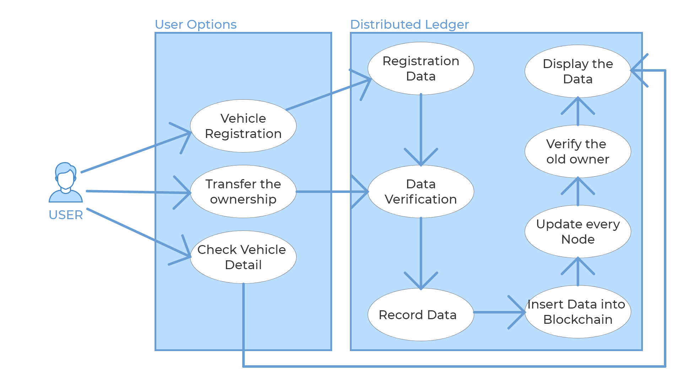

3.2 Functional Requirement
This System just looks like a database application to manage vehicle records, but it is more than this. Functional requirements of this system are described below.
- The system will be Immutable
Record which will be stored in blockchain is immutable and cannot be changed easily as explained above. Also, the data is added to the block after it is approved by everyone in the network and thus allowing secure registration.
- The system will be decentralized
The system will be Decentralized as well as an open ledger. Ledger is the record of the vehicle and because it is visible to everyone, therefore is called an open ledger. No individual or any organization will be in-charge of the records. Every connection in the blockchain network will have a same copy of the ledger.

- The system will be p2p network
The characteristic of blockchain allows the transactions to involve only two parties, the sender, and the receiver. Thus, it removes the requirement of ‘third party authorization’ because everyone in the network is themselves able to authorize the transactions.

3.3 Non-Functional Requirement
Non-Functional Requirements includes the following system attributes:
Accessibility, Capacity, current and forecast, Compliance, Documentation, Disaster recovery, Efficiency, Effectiveness, Extensibility, Fault tolerance, Interoperability, Maintainability, Privacy, Portability, Quality, Reliability, Resilience, Response time, Robustness, Scalability, Security, Stability, Supportability, Testability

Chapter 4

Design and Architecture
4.1 System Architecture / Process Flow
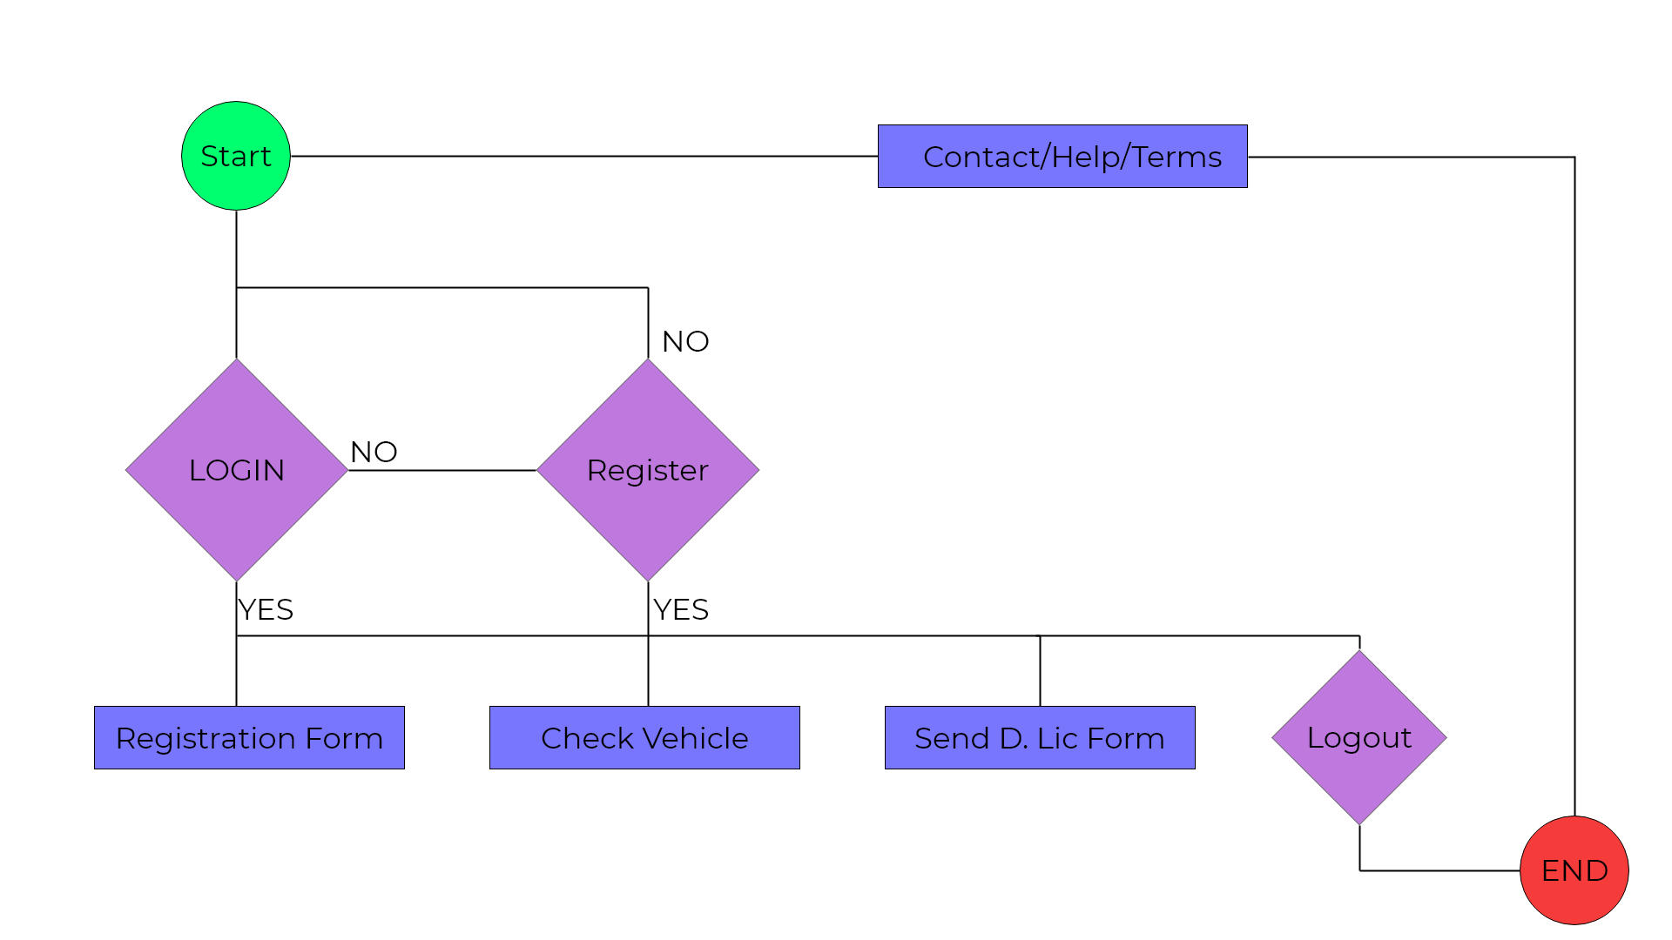
4.2 Entity Relationship Diagram
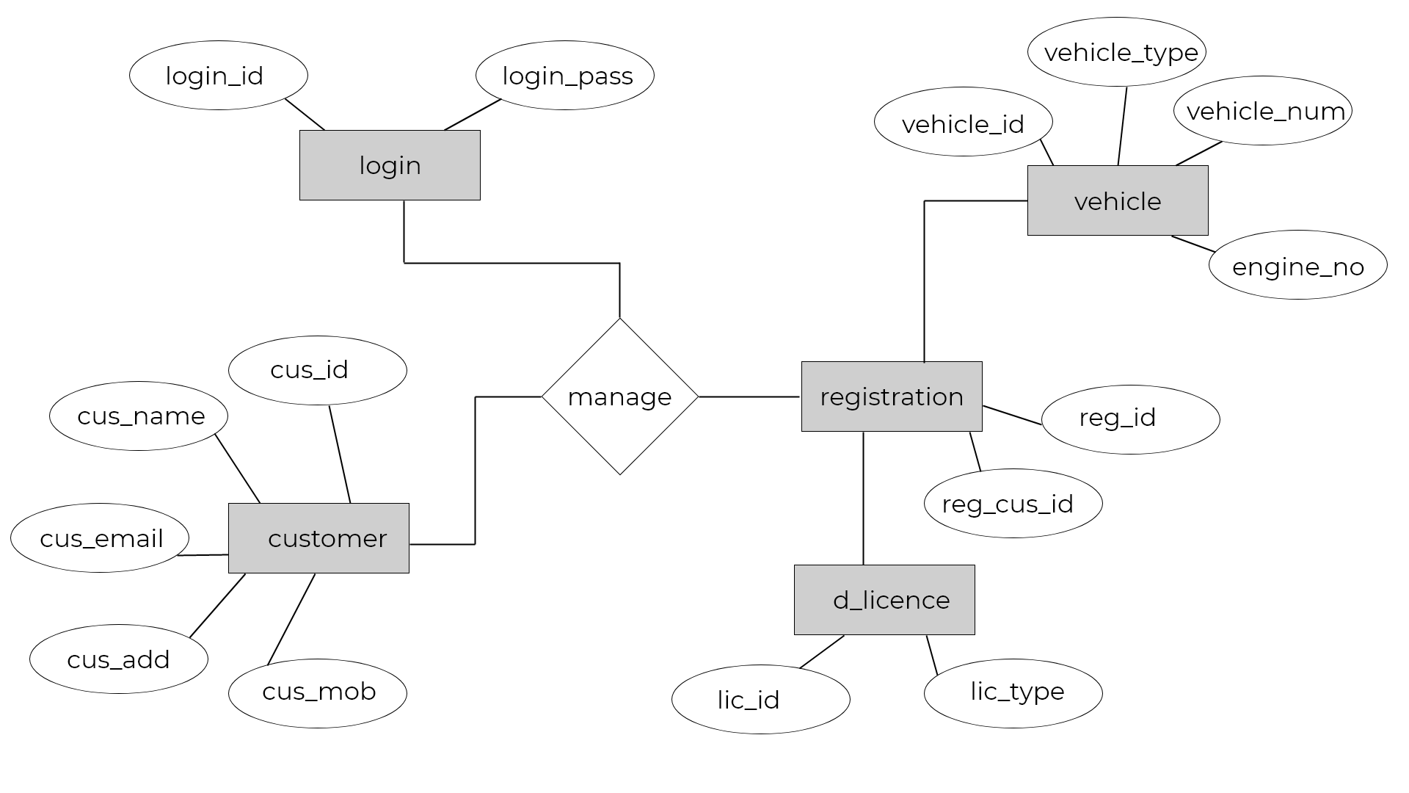

Chapter 5

IMPLIMENTATION AND EXECUTION
5.1 Algorithm
Proof of Authority (PoA) is a consensus algorithm type based on the reputation of trusted parties in a blockchain network. The Proof of Authority model works on a fixed number of block validators, making it an easily scalable blockchain system because transactions are checked by already-approved network participants. A consensus algorithm is a procedure through which all the peers of the Blockchain network reach a common agreement about the present state of the distributed ledger. Thus, a consensus algorithm aims at finding a common agreement that is a win for the entire network.
For encrypting SHA-256 hashing algorithm is used.
Blockchains generally use the SHA-256 hashing algorithm as their hash function. Cryptographic hash functions provide the following benefits to the blockchain: Avalanche effect, A slight change in the data can result in a significantly different output.
In the project, Blockchain for vehicle registration, both the consensus and SHA-256 algorithms are used to make the system work smoothly and flawlessly.

5.2 User Interface
Login Page
In every system there are some authorized people who have access to the data. To give access rights, administrators first give permissions to the valid persons.
Similarly, in our Blockchain vehicle registration system, where data’s security is very important. So, to secure the data we have a login page to ensure that only authorized people are allowed in system.
The login page keeps the necessary checks and response accordingly, such as whether the fields are empty or not: if empty then the popup will display that the field(s) empty, inserted data is formatted or not such as character limits in password etc. Or in other case it will say that the user with the following username is not registered with the system.
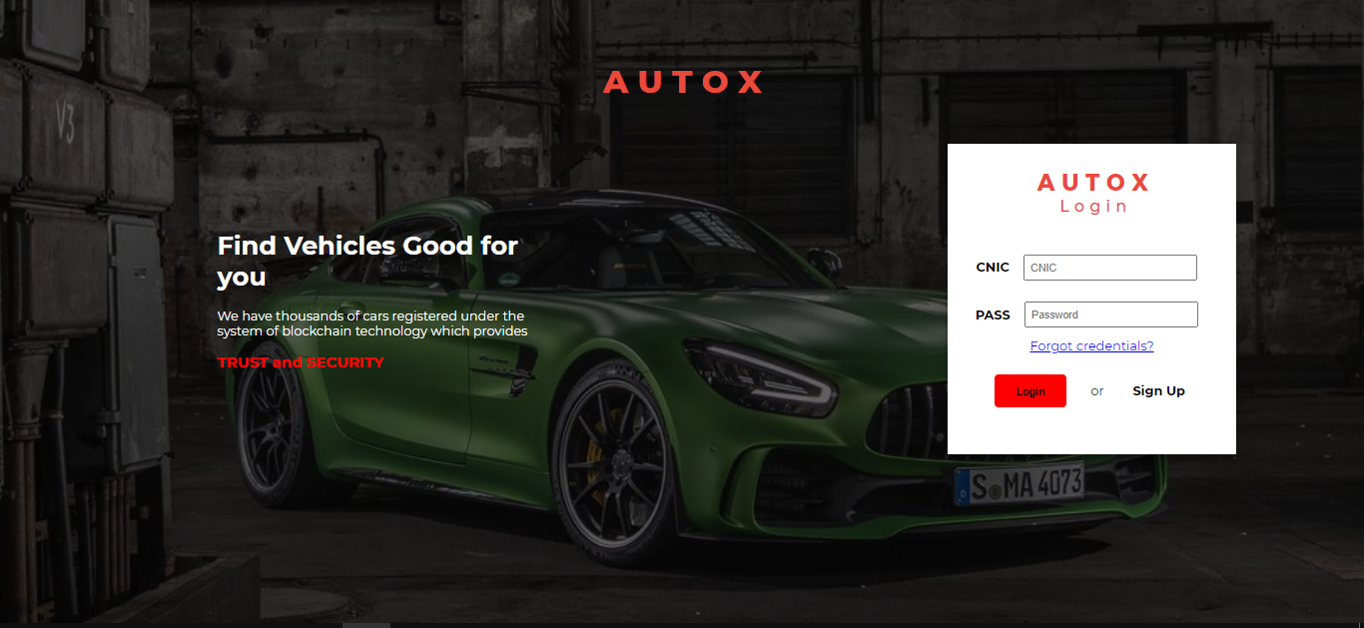
Signup Page
For new person who either wants to be part of the system or any one who is in registration office but does not registered with the system, we have a sign up page. 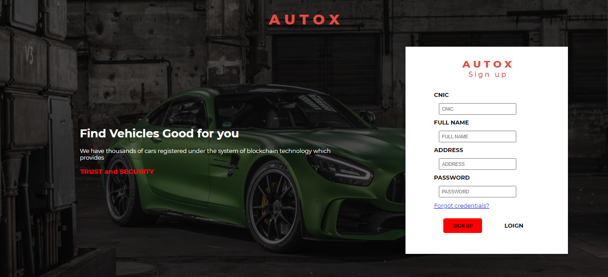
Person’s Dashboard
A dashboard is a screen in application that displays information about the user. Normally, a dashboard provides the user a global overview, with access to the most important data, functions and controls. In reality, a dashboard often becomes a sort of homepage, especially for power users.
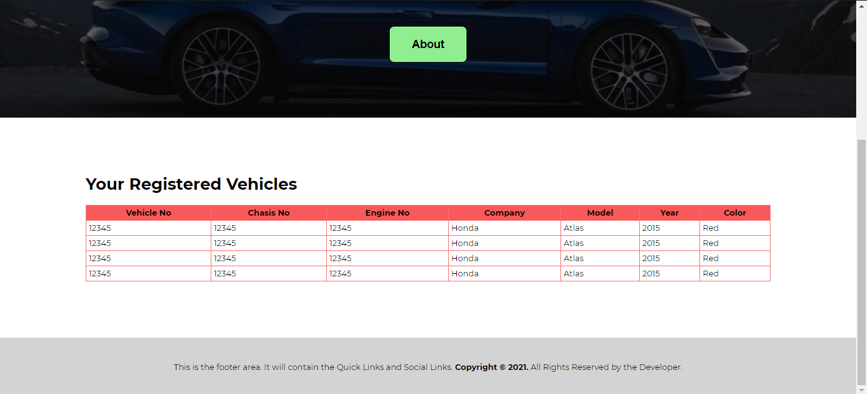

To Register A New Vehicle
The system’s basic operations is to register new vehicles with zero frauds and errors. So for that purpose.
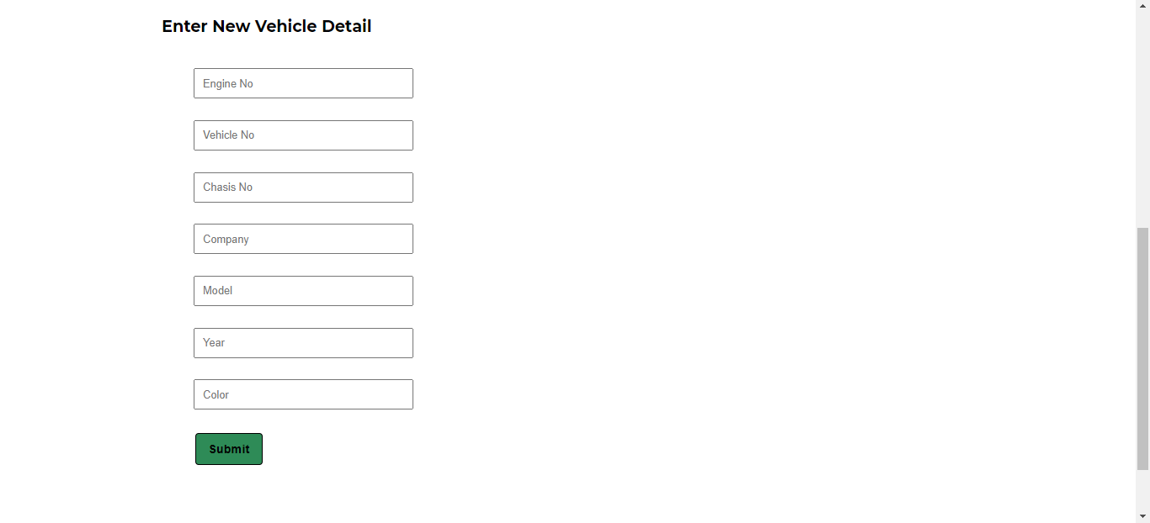

Chapter 6

Testing and Evaluation
6.1 Testing and Evaluation
From the development point of view, each and every module has been checked and verified. The test modules include user verification (login/signup) process to the vehicle registration and other transactions.
User verification is also an important task while developing the system, because we want to secure the system from the zero level and our first priority is to make a loop-hole free block-chain.
Vehicle Registration includes
- Entering a Record of New Vehicle to the system
- Entering a Record of Vehicle being sold to customer from show-room
- Entering a Record of Vehicle being transferred from one owner to another owner

Phase to test | Test Description | Expected Results | Actual Results
Login page | Page should accept user response while login. | Page will be working perfectly fine in any situation. | Pass
Signup page | User should be added to the system. | User should have no issue in normal cases to become part of the system. | Pass
Vehicle Registration | Record should be entered and accepted by the system if there is no error / fraud. | Vehicle should be registered or rejected according to the situation. | Pass
Controls | Controls should work in proper manner like only authorized person has the rights to alter / upload the data. | If someone with no rights try to alter the data must not be allowed. | Pass
Transfer of ownership | Owners must be the part of system to sell or buy vehicles. | No one can sell or buy if authorized person does not allow. | Pass

Chapter 7

Conclusion and Future Work
7.1 Conclusion
If you have followed every chapter, not have only you deepen your understanding of our project, its development and designing process, but you have also noticed the importance of this project for society.
We gave our best to explain every aspect of each individual part, so it will not cause confusion. Each chapter explains everything about the project step by stem, and each chapter briefly describes what and how we did it.

7.2 Future Work
We want this project to be in excise and taxation office. While the project was in development phase, our goal was to bring our efforts live to make a fraud and error free system.
We put our efforts to the end, now see how long the project take to get functional.
Our future plan is to develop same technology-based system for different areas like pharmacy and schools etc.
Page left intentionally blank…!

Appendix A

- https://www.google.com/search?q=blockchain&oq=blockchain&aqs=chrome.0.0j69i60l2j0l4.1791j0j9&sourceid=chrome&ie=UTF-8
- Tiago Rosado Instituto Superior Técnico, Universidade de Lisboa, Portugal.
André Vasconcelos INESC-ID, Instituto Superior Técnico, Universidade de Lisboa, Portugal. Miguel Correia INESC-ID, Instituto Superior Técnico, Universidade de Lisboa, Portugal. “A Block Chain Use Case for Car Registration,”
- https://www.researchgate.net/publication/332977375_Blockchain_Technologies_in_E-commerce_Social_Shopping_and_Loyalty_Program_Applications

